Farhan Ali Rizwan  
roll no 12  
BSDS-3A  
Submitted to: Rashikh Ali  
  
Smart Home Temperature Control

Description:

Imagine a smart home with multiple rooms. Each room has a thermostat that controls the heating system. The goal is to maintain a comfortable temperature in each room (e.g., 22°C). The smart home system is equipped with a Simple Reflex Agent that can: • Sense the current temperature of each room. • Turn the heater on if the temperature is below 22°C. • Turn the heater off if the temperature is 22°C or above. We will also explore a Model-Based Reflex Agent that remembers whether the heater was on or off in the previous cycle to avoid redundant actions

**Program**

class SimpleReflexAgent:

    def __init__(self, fixed_temp):

        self.fixed_temp = fixed_temp

        self.current_temp = None

    def sensor(self, temp):

        self.current_temp = temp

    def performance(self):

        action = None

        if self.current_temp < self.fixed_temp:

            action = "Turn ON the Air conditioner"

        else:

            action = "Turn OFF the Air conditioner"

        return action

    def actuator(self):

        action = self.performance()

        print(f"Room Temp = {self.current_temp}°C => Action: {action}")

agent = SimpleReflexAgent(22)

rooms = {

    "Living Room": 30,

    "Drawing Room": 22,

    "Kitchen": 34,

    "Store Room": 20,

    "Kill Room: Tonight the night, it is going to happen again": 20

}

for room, temp in rooms.items():

    print(room, end=":\t")

    agent.sensor(temp)

    agent.actuator()

Output:

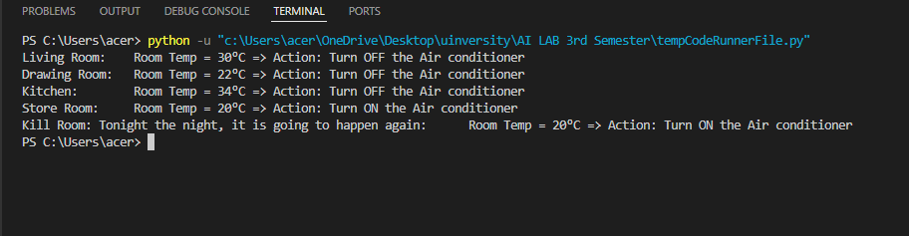

Explanation :  
Here’s the **explanation in short key points** only:

* A class Simple Reflex Agent is created to control room temperature.
* __init__ sets the target (fixed) temperature and initializes current temp.
* Sensor () updates the agent with the current room temperature.
* performance() compares current temp with fixed temp and decides the action:
  + If below fixed → **Turn ON Air conditioner**
  + Otherwise → **Turn OFF Air conditioner**
* Actuator () calls performance () and prints the room’s temperature with the chosen action.
* A dictionary rooms stores multiple room names and their temperatures.
* A loop goes through each room, senses the temperature, and runs the actuator.
* The output shows each room’s temperature and the action taken by the agent.